1. Open the brackets and translate the world: My **( мұрын )** can smell.
2. Eye b) nose c) ear
3. Translate the sentence: **I can skip.**
4. Мен жаза аламын
5. Мен оқи аламын
6. Мен секіртпе жіппен секіре аламын
7. Complete the sentence: **How ____________ you?**
8. Is
9. Are
10. Am
11. Where is the schoolbag? 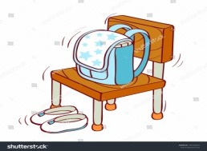

**In, on, under.**

The schoolbag ____________ the chair.

1. How many days a week?
2. six
3. nine
4. seve
5. Look, read and complete

**Skip, sing, dance, jump**

I can _____________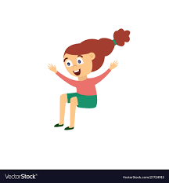 I can _____________

I can _____________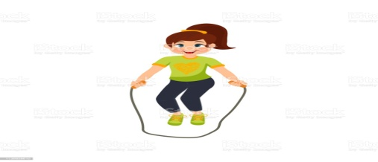 I can _____________

1. Fill in the missing letters.

**a, e, k, i, b**

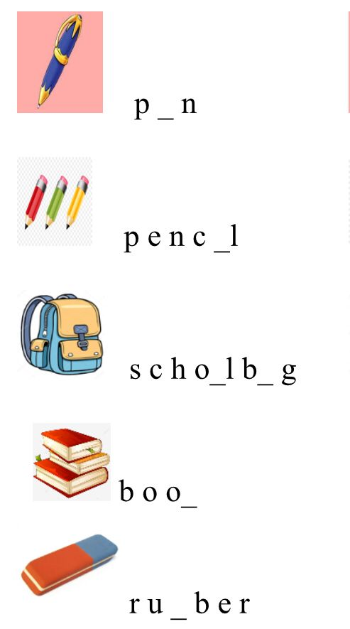

1. Circle the **hot** foods

    

1. Who are they in the family?

**brother, daddy, grandma, sister, mummy, grandpa**

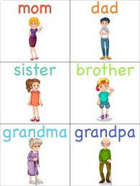     

_________ _________ ____________ __________ __________ ____________

1. Read and colour.

Green apples red tomatoes

Orange carrots yellow bananas

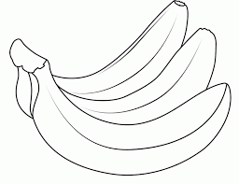 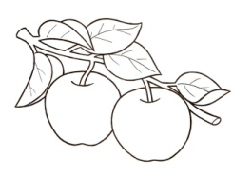 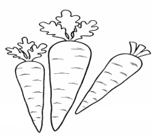 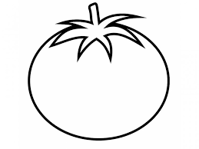

1. Сhoose, put a tick ( ) what Kate has got:

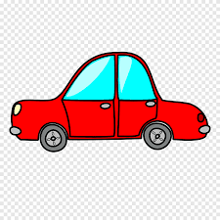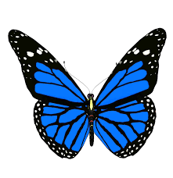

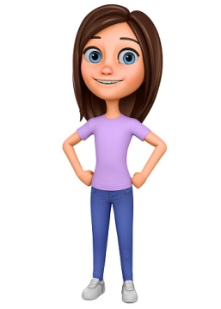

a car a butterfly an ball a plane

a bus a book a pen a rabbit

1. Мұғаліммен қалай қоштасады
   1. Good morning teacher!
   2. Goodbye teacher!
   3. Hello teacher!
2. Бұл сұраққа қалай жауап береді.

How are you!

- _____________

A. I am seven

B. I am fine!

C. I like banana

14. Жануар аты мен суретін сәйкестендір.

Horse 🐎 mouse 🐁 fish 🐟 bear 🐻 monkey 🐒